LiFi Receiver Node Documentation

Overview
The LiFi Receiver Node receives data transmitted through visible light using an LDR sensor. An ESP32 processes the detected light pulses, decodes the received information, and displays the decoded message on a 16x2 I2C LCD. The receiver is designed for reliable short-range optical communication in indoor environments.

Purpose
This module serves as the receiver in the LiFi Wireless Communication System. It detects optical signals from the LiFi transmitter and converts them into readable text displayed on the LCD. The implementation uses an ESP32, LDR module, and I2C LCD. The uploaded code initializes the LCD at I2C address 0x27, uses GPIO18 for the LDR input, and GPIO21/GPIO22 for I2C communication.

Hardware Components
- ESP32 DevKit V1
- LDR Module
- 16x2 I2C LCD (0x27)
- Breadboard
- Jumper Wires
- USB Power Supply

Pin Connections
Component | ESP32 Pin
LDR DO | GPIO18
LCD SDA | GPIO21
LCD SCL | GPIO22
LCD VCC | 5V/VIN
LCD GND | GND
LDR VCC | 3.3V
LDR GND | GND

Working Principle
- ESP32 initializes the LCD and I2C interface.
- The LDR continuously monitors light intensity.
- Incoming LiFi light pulses are converted into digital data.
- The ESP32 decodes predefined pulse patterns into messages.
- The decoded message is displayed on the LCD in real time.

Software Details
The receiver firmware is written in Arduino C++. It uses the Wire library for I2C communication and the LiquidCrystal_I2C library for LCD control. The program reads the LDR on GPIO18 and maps received pulse durations to predefined text messages for display.

Features
- Real-time LiFi reception
- ESP32-based processing
- 16x2 LCD message display
- Simple optical communication
- Low-cost hardware
- Educational IoT implementation

Code’s
#include <Wire.h>
#include <LiquidCrystal_I2C.h>
LiquidCrystal_I2C lcd(0x27,16,2); // set the LCD address to 0x27 for a 16 chars and 2 line display
void setup()
{
lcd.init(); // initialize the lcd
lcd.backlight();
}
void loop()
{
lcd.setCursor(0,0);
lcd.print("Welcome to Li-Fi Lab.");
lcd.setCursor(0,3);
lcd.print("Li-Fi transmission ");
lcd.setCursor(0,2);
lcd.print("systems.");
delay(3000);
lcd.clear();
lcd.setCursor(0,0);
lcd.print(" Developed by");
delay(1000);
lcd.setCursor(0,2);
lcd.print(" Raushan Kumar.");
delay(4000);
lcd.clear();
lcd.setCursor(0,0);
lcd.print(" Thank You ");
lcd.setCursor(0,2);
lcd.print(" ***********");
delay(3000);
}

LDR Esc Working With LIFI code
#include <Wire.h>
#include <LiquidCrystal_I2C.h>

LiquidCrystal_I2C lcd(0x27, 16, 2);

#define LDR_PIN 18

String duration = "";

void setup() {
Serial.begin(9600);
Wire.begin(21, 22);

pinMode(LDR_PIN, INPUT_PULLUP);

lcd.begin();
lcd.backlight();
lcd.clear();

lcd.print("LiFi Project");
delay(3000);

lcd.clear();
lcd.print("Send any message");
lcd.setCursor(0, 1);
lcd.print("from LiFi App..");
delay(3000);
}

void loop() {

int val = digitalRead(LDR_PIN);

while (digitalRead(LDR_PIN) == 0) {
int val2 = digitalRead(LDR_PIN);

if (val2 == 0) {
duration += "0"; // ADD ONLY ZEROES
}

if (val2 == 1) {
break; // DON'T RESET HERE
}

delay(200);
}

if (duration.length() > 0) {

// Debug print
Serial.println(duration);

if (duration == "00") {
lcd.clear(); lcd.print("hi");
}
if (duration == "000") {
lcd.clear(); lcd.print("hello");
}
if (duration == "0000") {
lcd.clear(); lcd.print("how are you?");
}
if (duration == "00000") {
lcd.clear(); lcd.print("I am fine");
}
if (duration == "000000") {
lcd.clear(); lcd.print("ok");
}
if (duration == "0000000") {
lcd.clear(); lcd.print("good morning");
}
if (duration == "00000000") {
lcd.clear(); lcd.print("good afternoon");
}
if (duration == "000000000") {
lcd.clear(); lcd.print("good evening");
}
if (duration == "0000000000") {
lcd.clear(); lcd.print("thank you");
}
if (duration == "00000000000") {
lcd.clear(); lcd.print("sorry");
}

duration = ""; // finally RESET
}
}

Circuit Diagram
+-----------------------------+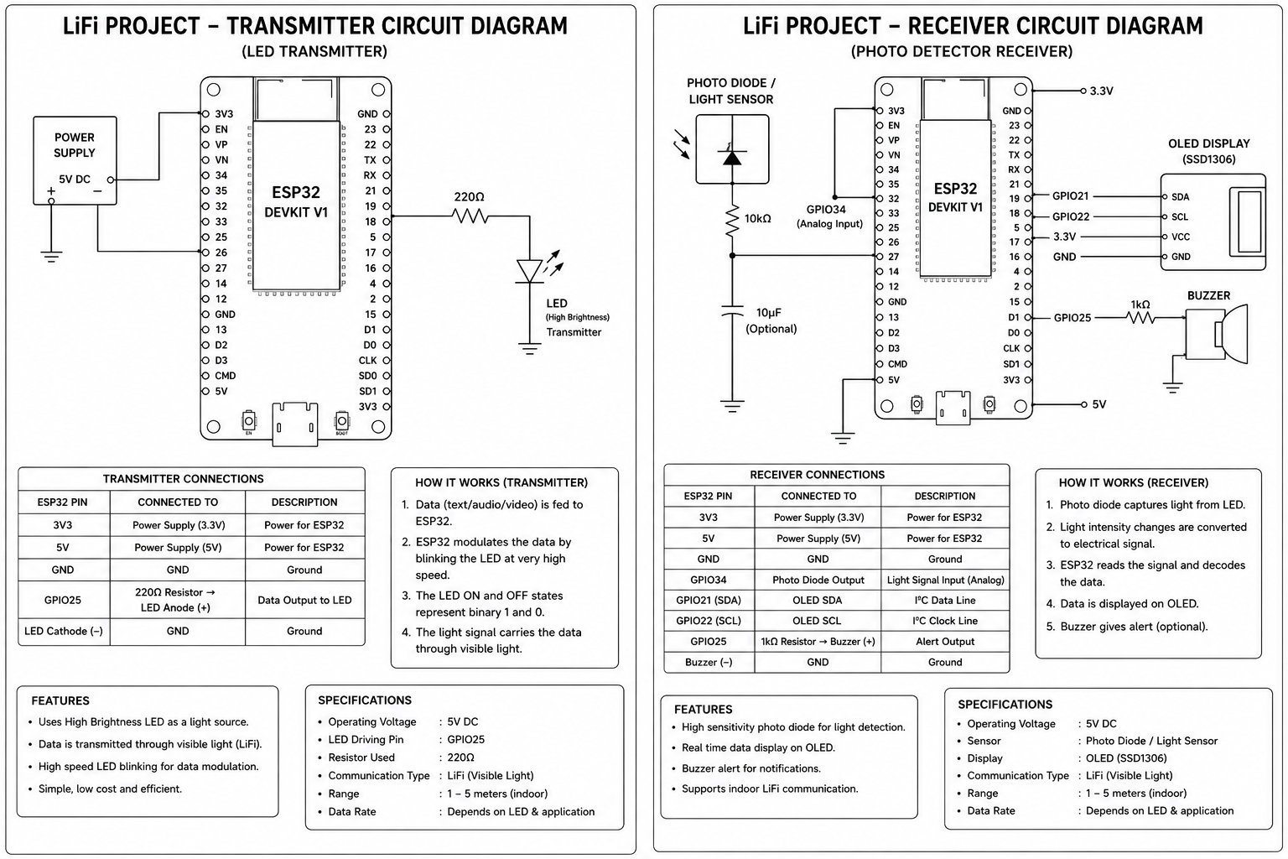

| ESP32 DevKit |
| |
| 3.3V o-------------+----------------+
| | |
| GND o-------------+---------+------+
| | |
| GPIO18 o----------------------------+ |
| | |
| GPIO21 (SDA) o-----------------------------+
| GPIO22 (SCL) o----------------------+ |
+-------------------------------------|------+
|
+--------------------------------------+----------------+
| |
| LDR MODULE |
| |
| VCC ------------------------- 3.3V |
| GND ------------------------- GND |
| DO -------------------------- GPIO18 |
+-------------------------------------------------------+

+-------------------------------------------------------+
| 16x2 I2C LCD |
| |
| VCC ------------------------- 5V (or VIN) |
| GND ------------------------- GND |
| SDA ------------------------- GPIO21 |
| SCL ------------------------- GPIO22 |
+-------------------------------------------------------+

